Join an Altus for Women Book Group!

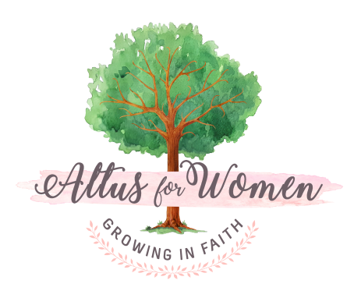
Do you wish you knew more about your Catholic faith? Does your faith need refreshing? Would you like to meet other women of faith for support and encouragement? Starting this fall, you can join women throughout the diocese, meeting monthly in small groups to read and discuss a different Catholic book every month, year round! We will read books by inspiring authors such as Teresa Tomeo, Scott Hahn, Johnette Benkovic Williams, and C.S. Lewis, just to name a few!
Altus Book Groups are sponsored by Altus for Women, a Catholic women’s ministry in partnership with the Diocese of Scranton's Office for Parish Life. Altus Book Groups are FREE and open to all women. Our local Altus Book Group will meet (insert your meeting day of the month, time, and location here). Please contact (insert your name, phone # and/or email address here) to join the Group! Learn more about Altus at www.altusforwomen.com.

