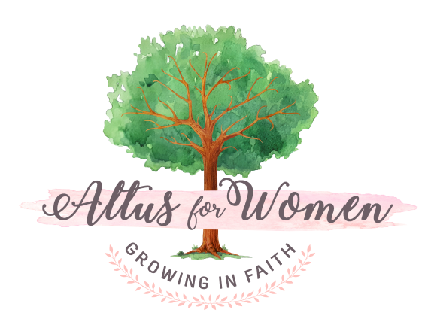

Facebook Directions for Online Group and Altus for Women Chat

To sign up for the closed Bible Basics Online Facebook (FB) Group, follow these steps:

1. Log onto your FB account
2. Search for "Bible Basics for Catholics Online Altus Group"
3. Click the "Join Group" button
4. We will "approve" your membership in the Group and you can begin posting, reading, liking, and commenting on the posts of other Altus friends!

To sign up for the closed Altus for Women Chat FB Group, follow the same process:

1. Log onto your FB account
2. Search for "Altus for Women Chat"
3. Click the "Join Group" button
4. We will "approve" your membership in the Group and you can begin posting, reading, liking, and commenting on the posts of other Altus friends!

