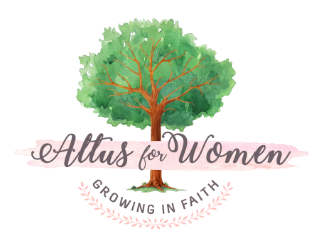
Altus Book Group Discussion Questions/Prompts (for ALL books!)
Choose as many (or as few) as you would like & feel free to add your own!

What did you like most about this book?
What did you like least about this book?

How did this book change your understanding of your faith?

What is something you learned from this book?

How will you apply what you learned?

What do you think God wants to show you as you relate the concepts in this book to your life?

What was your favorite chapter of the book? Why did this chapter stand out?
What was your favorite quote or line from the book? Why did this quote/line stand out?
Did the book make you cry? Laugh? Squirm? Feel nervous? Hopeful? Calm? Refreshed? Explain the strongest emotion you experienced as you read. Share why you think this was so.

What is something in the book you can relate to? Why?

Is there something in the book you disagree with? Explain.
If you got the chance to ask the author of this book one question, what would it be?
Does this book inspire you to do more reading about a certain topic? What is that topic?

What song or songs came to mind while reading the book? Create a Book Group playlist!

