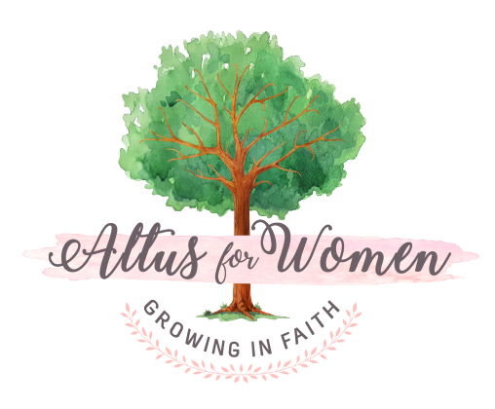
Small Group Guidelines
Cultivate the art of listening. Try not to think of what you are going to say while someone else is talking. Be attentive to the speaker and give your full attention.

Make sure everyone in your group has a turn speaking. If you find you have a lot to say, try holding back until others have had a chance to speak.

Avoid getting into a “private” discussion with just one person at the table. Wait and share your ideas with everyone present. You have something to say, and everyone wants to hear it!

Confidentiality is important in relationship building. But remember, whatever is shared in the group must stay in the group. Never discuss things mentioned in the group with anyone outside the small group.

Stick to the subject being discussed. If you wander, you will be gently redirected! This is to make maximum use of our time together. So, no “rabbit trails”, please!

Embrace periods of silence! Sometimes we need time to think about what we are learning, or need time to answer a question…. so don’t be afraid of the quiet. Part of the beauty of Altus for Women is the silence we need for refreshing our souls.

Altus for Women meetings are a time for adult reflection and renewal. Therefore, please plan on coming by yourself to the meetings, leaving children with a caretaker. If you are having difficulty finding childcare, please speak with your Altus Hostess.

Please do not invite visitors or newcomers to the group now that it has started. It affects the group dynamics and the comfort of the existing group members. If you think of someone you’d like to experience Altus, be sure to invite them to the next course offering!

Please enjoy yourself! Ask questions and learn from the other women you meet.

Thanks for joining us. If you should have any difficulty during the course, please feel free to speak to your Altus Hostess for assistance. She is here to help you!

