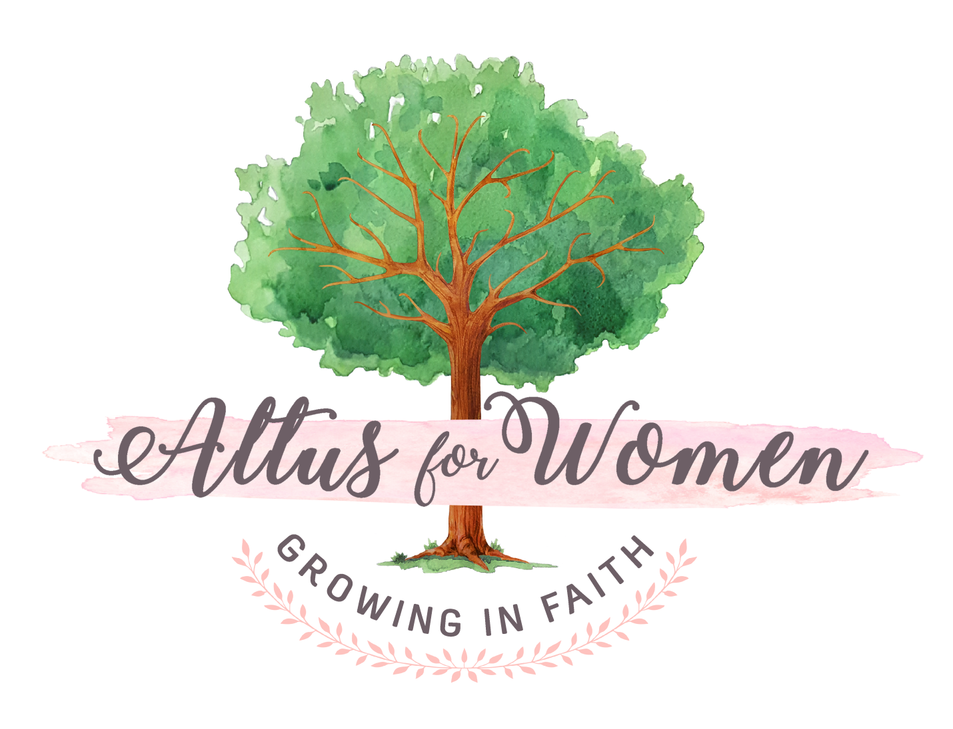

Mary's Way Weekly Reading/Discussion Schedule

Session 1 (Initial Kick Off Gathering): No advance reading needed for this gathering! The "homework" will be to read the Forward, Introduction, and Chapter 1 (pp. ix-30) and to answer the "Ponder" questions on pp. 13 & 29.

Session 2: During this gathering, we will discuss the "Ponder" questions from the Introduction and Ch. 1. The homework for the next gathering will be to read Chs. 2 & 3 (pp.31-64) and answer the "Ponder" questions on pp. 44 & 63.

Session 3: During this gathering, we will discuss the "Ponder" questions from Chs 2 & 3. The homework for the next gathering will be to read Chs. 4 & 5 (pp.65-97) and answer the "Ponder" questions on pp. 78 & 96

Session 4: During this gathering, we will discuss the "Ponder" questions from Chs. 4 & 5. The homework for the next gathering will be to read Chs. 6 & 7 (pp.99-140) and answer the "Ponder" questions on pp. 118 & 139.

Session 5: During this gathering, we will discuss the "Ponder" questions from Chs. 6 & 7. There is no homework!

