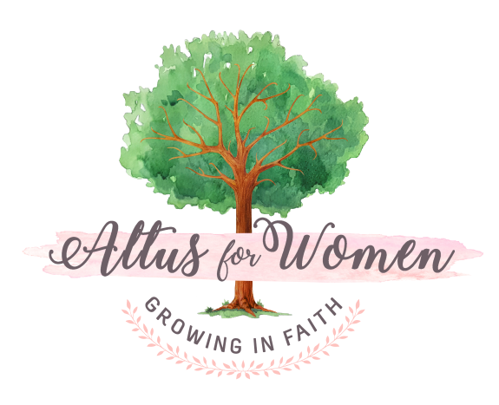
Small Group Leadership Skills

Thank you for agreeing to be an Altus Hostess! As a small group leader, you actually are a coach, cheering on those in your small group or “team”. Our hope is that you will help each participant to deepen her spiritual life, recognize the gifts she has, and feel loved and cherished just for who she is ~ a child of the Most High God.

Before the study begins please:
- Familiarize yourself with the names of those in your group
- Pray for each member of your group by name
- Spend time in prayer for the other group leaders, Altus for Women, and yourself!

Kick Off ~ Goal #1: Greeting Participants
The first goal of our Kick Off gathering is to welcome women to Altus!
- Greet everyone personally. Do your best to identify those in your group, recognizing their names. Introduce yourself to whomever you meet.
- Help women find name tags and the table where their group will meet.
- Offer guests refreshments.
- Show guests around ~ group tables, restrooms, refreshment table, etc.
- If you notice anyone standing or sitting alone, talk with her and introduce her to other women.

Kick Off ~ Goal #2: Getting the Small Group Going
The second goal of the Kick Off is to help everyone to feel comfortable and to get to know their group members. Here are some tips you can use to ease the tension of new members:
- Help people remember each other’s names. For instance, ask people to say their name and an adjective that describes them that begins with the same first letter (e.g., Serene Sarah, Laughing Laura, Caring Cathy)
- Spend some time using the "Ice Breakers" listed on the last page of these guidelines.

Kick Off ~ Goal #3: Explaining the Course
The third goal of the Kick Off is to help the women know what to expect at the local group gatherings:
- Explain what will happen at each gathering (i.e., opening prayer, small group study guide discussion, announcements, closing prayer).
- Briefly look over the book and study guide so that the women will understand what "homework" needs to be done in between meetings. Please encourage women to attend even if they don't finish all of their homework!
- Explain that this is a study that needs consistent attendance for it to be fruitful in women's lives. Ask them to please try to attend every week!
- Privacy: please don’t invite newcomers or visitors. This disrupts the continuity of the group.

Stages of Small Group Life

1. Forming: Everyone is unsure. There is anxiety. What will my group be like? Will I like it? Who is in my group?

2. Storming: Group members evaluate and observe each other. May cause group tension as different styles and ideas emerge. I’m not sure I like _______.

3. Norming: Group dynamics settle down. Everyone knows what to expect and begins to understand different personalities. Comfort increases.

4. Mourning: Group members mourn the loss of intimacy and meeting weekly with those they have formed new relationships. Make time for proper closure.

Effective Group Discussion

Group leaders facilitate discussion in 4 effective ways: ACTS

A: Acknowledges everyone who speaks during a discussion. Remember to also acknowledge non verbal communication: “Lisa, you look like you don’t agree”.

C: Clarify what is said. After someone complains about one friend after another who betrays her confidence, say …. “Let me see if I understand what you are saying. You feel that you have never had a friend that can be trusted. Is that right?

T: Turn it back to the group. Don't be the answer person. Ask, “What do others of you think about what was just said?”

S: Summarize what has been said. “So far, it seems like we are saying….” Or "Lisa, would you like to summarize the key thoughts of the discussion?”

Asking Questions and Giving Responses

A key to generating good discussion is using the right types of questions and having good responses.
Launching questions: Questions that promote discussion
Do you agree?
What do we learn from this?
What two things did the author mention about_____?
Did you ever feel that way?

Affirming responses:
Laura, this is such a hard time for you. I’m sorry you are going through this.
Lisa, Thanks for sharing your thoughts. You have some good ideas.
Barb, that is a great question. Has anyone ever wondered the same thing?

Observing Non-Verbal Communication

Facial expression: When someone says, “I’m ok” does their facial expression
communicate, “I’m really a little sad?”
Tone of voice: Listen for tones of sarcasm, anger, sadness, hesitancy, fear, enthusiasm.
Body movement or posture: Are they fidgety or relaxed? Does their posture indicate interest or boredom? Are they leaning forward like they want to speak but never do?

Follow up on non-verbal cues. This allows people to know they are loved and valued. Say, “You look upset. Is there something we can do?” or, “You don’t look ok! Do you want to talk about it?” “Lisa, you’re shaking your head. Do you disagree?”

Tools for Redirecting: NO RABBIT TRAILS!

Set yourself up properly by giving warning ahead of time (during the Kick Off session) that you will not allow rabbit trails. Rabbit Trails are when women go off on tangents not related to the assigned questions/topics to be discussed.

DURING THE KICK OFF, give an example of how you will redirect rabbit trails:
“Lisa, I love what you are talking about but I’m going to redirect us back to the topic now…We can pick this up at the snack time or after the group tonight.”
The most important thing you can do for your group is not to allow rabbit trails. If
someone is “needy”, setting yourself up ahead of time is essential so that they don’t feel as though the redirect is personal.
Please let your Pastor know if you have someone that is in need of a little extra care or attention or if they have “counseling” needs.

Icebreakers for your Small Group (choose ones that appeal to you!)

People might be surprised to find out that I…….
My favorite way to waste time is...
What’s the story of the longest time you have gone without sleep?
If you could do one miracle, what would it be?
What do you miss most about childhood?
If you could go to college (again), what would you study?
What is the worst storm or disaster you’ve been in? What was it like?
What day of your life would you like to relive? Why?
What’s the smallest space you lived in? What was it like?
As a time traveler, I would most like to visit______ because______.
Next year looks better to me because____________.
Next year may be a problem because____________.
I am most like my mom because _________.
I am most like my dad because_________.
I have never quite gotten the hang of__________.
What are two things you remember about your grandparents?
What is the nicest thing anyone ever did for you?
What is the nicest thing anyone ever said to you?
Where do you go or what do you do when life gets too “heavy” for you?
What is one of the worst or most annoying things your brother or sister did to you when you were little?
What was your first job? What do you remember most about it?
How many siblings do you have? Where are you in the birth order?
What is your biggest fear about the future?
The most useless thing in my house is_________ and it’s still there because ________.
Take something out of our wallet or purse that tells something about yourself. Describe it and what it tells about you.
What is one thing most people don’t know about you?
What is one hobby that you have?
Describe your favorite bathrobe.

