Grow in Faith with Altus for Women This Fall!
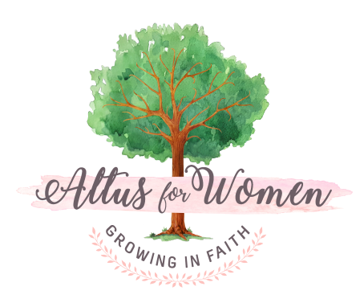
“You’re Catholic. You know you ought to know the Bible better than you do, and you feel vaguely guilty that you don’t. Come on, admit it. You know it’s true! " -- Dr. John Bergsma, author of Bible Basics for Catholics
We know EXACTLY what he means: We all would like to study the Bible, but we're not sure where to start. We’d LOVE to take a class, but we’re busy (and who wants to go back to school?!). We’ve tried Bible studies before, but almost none of it reaches our minds or hearts.
This Fall, let award-winning Professor Bergsma (from Franciscan University of Steubenville) guide you through a high energy and entertaining walk through the Bible, illustrated with his own charming STICK FIGURES! A book so fresh, engaging, and instructive, you’ll find yourself smiling as you read it and be amazed at what you retain.

(add your parish name here) will have an Altus Group meeting for 5 sessions from (add your Group’s dates and time and building location here). For more information, please contact (add your name, phone # and email address here). Registration fee is $20 (plus the cost of the book). Information about purchasing the book can be found at www.altusforwomen.com. Online registration/payment opens September 4th at www.altusforwomen.com. Please join us!

Altus for Women is a Catholic women’s ministry in partnership with the Diocese of Scranton Office for Parish Life.

