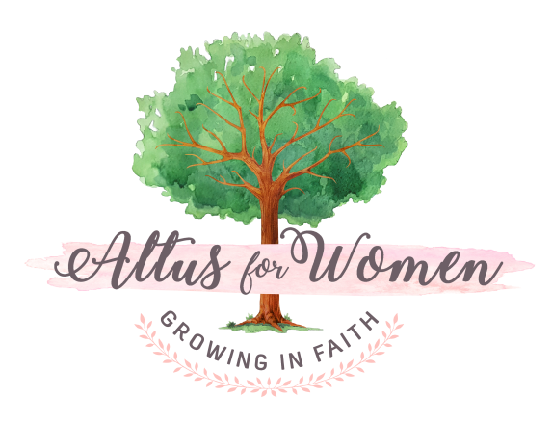

"Mary's Way" & "Bible Basics" Hostess Gathering
October 3, 2018

6:30 Gather, chat, snack

6:45 Welcome, Prayer, Opening Announcements

6:55 Explain:
- Altus Boxes
- Rosters & Nametags
- “Hostess Help” document
- Agenda for Week 1
- Introductions/Icebreakers
- Small Group Guidelines
- Snack Sign Up Sheet
- Collect Contact Information
- Weekly Reading/Discussion/Assignment Schedules
- Online "Bible Basics" FB Group
- Directions for Altus Chat Facebook Page

- Agenda for Weeks 2-5

7:25 Break

7:35 Q & A forum

7:55 Closing Announcements & Prayer

